2nd Semester: Professional Communications Exam

- Words or phrases that indicate speaker has completed one thought and is moving to another are called
  - Transfers
  - Speech bridges
  - Transitions
  - None of the above

- The process of sending & receiving messages is:
  - Talking
  - Listening
  - Communicating
  - Lying

- Personal attitudes or behaviors that interfere with listening
  - Talking
  - Children
  - Listening barriers
  - People

- The receiver’s response to a message that lets the speaker know how he or she is doing
  - Walking
  - Communicating
  - Feedback
  - Listening

- One who delivers the message
  - Receiver
  - Barrier
  - Communicator
  - Sender

- The one who gets the message & interprets what it means
  - Feedback
  - Communicator
  - Lawyer
  - Receiver

- Nervousness when addressing an audience
  - Scary
  - Stage freight
  - Funniness
  - Communication barrier

- Communication expressed without words; it includes facial expression, eye contact, posture & gesture
  - Verbal message
  - Verbally stated
  - Nonverbal message
  - Verbal tone

- Type of communication in which people (usually 2 persons) share meanings in order to build or maintain long-lasting & important relationships
  - Intrapersonal communication
  - Non-intrapersonal communication
  - Non-interpersonal communication
  - Interpersonal communication

- Speech that presents or describes information
  - Persuasive
  - Informative
  - Cooperative
  - Abundant

- Understanding the Career Cluster in high school can help to do all of the following except
  - Explore your interests and abilities
  - Learn what career options are out there
  - Plan what courses you should take in high school to prepare for your career choices
  - Figure out your GPA for college

- Choose the answer below that is not a description of CC (Carbon Copy)
  - It’s another way of sending someone else a copy of the email you sent to another person
  - When using CC, all recipients see who is receiving the message
  - CC originally meant carbon copy but has transitioned into “courtesy copy”
  - Hides the persons email address who’s sending the message

- Which of the below is a correct example of a subject line to your teacher
  - Communication Inquiry
  - Professional Communication-Sam
  - Professional Communications-Sam Smith-3
  - Erin-Homework

- Before sending an email you should do all of the following except
  - Check your grammar
  - Write in all caps
  - Proof read your email for errors
  - Be efficient-emails that get to the point are much more effective

- Choose a proper professional greeting for an email below:
  - Good MORNING Ms. Smith,
  - Hey!!!!!
  - Hello Mrs. Smith,
  - Good morning mr. smith

- Choose the proper professional ending for an email below:
  - thanks,
  - Thank Yoooooooou,
  - I appreciate your help,
  - Thanks again for ya!!!!!!!

- Communication with or within yourself; for example, thinking as well as talking aloud to yourself
  - Intrapersonal communication
  - Non-intrapersonal communication
  - Interpersonal communication
  - Non-interpersonal communication

- Speed in which the speaker talks
  - Pitch
  - Volume
  - Rate
  - Tone

- The part of the speech that contains all the main points & their supporting details
  - Introduction
  - Conclusion
  - Paragraphs
  - Body

- A question that is asked with no answer expected; it’s purpose is to direct the listeners thoughts is a
  - Question
  - Rhetorical question
  - Methodical question
  - Hard question

- The major purpose of an informative speech is to
  - Provide solutions to real problems
  - Share knowledge and ideas.
  - Clear up disputed issues.
  - Persuade the audiences to agree with your ideas.

- The space or means in which the communication is sent through
  - Feedback
  - Channel
  - Receiver
  - Message

Fill in the according circles that have been numbered with the correct word listed below. Some words maybe used more than once & others may never be used at ALL!
A. Channel
B. Noise
C. Barrier
D. Internal
E. Feedback
AB. Receiver
AC. Message
AD. Encoding
AE. Decoding
CD. Sender
BC. External

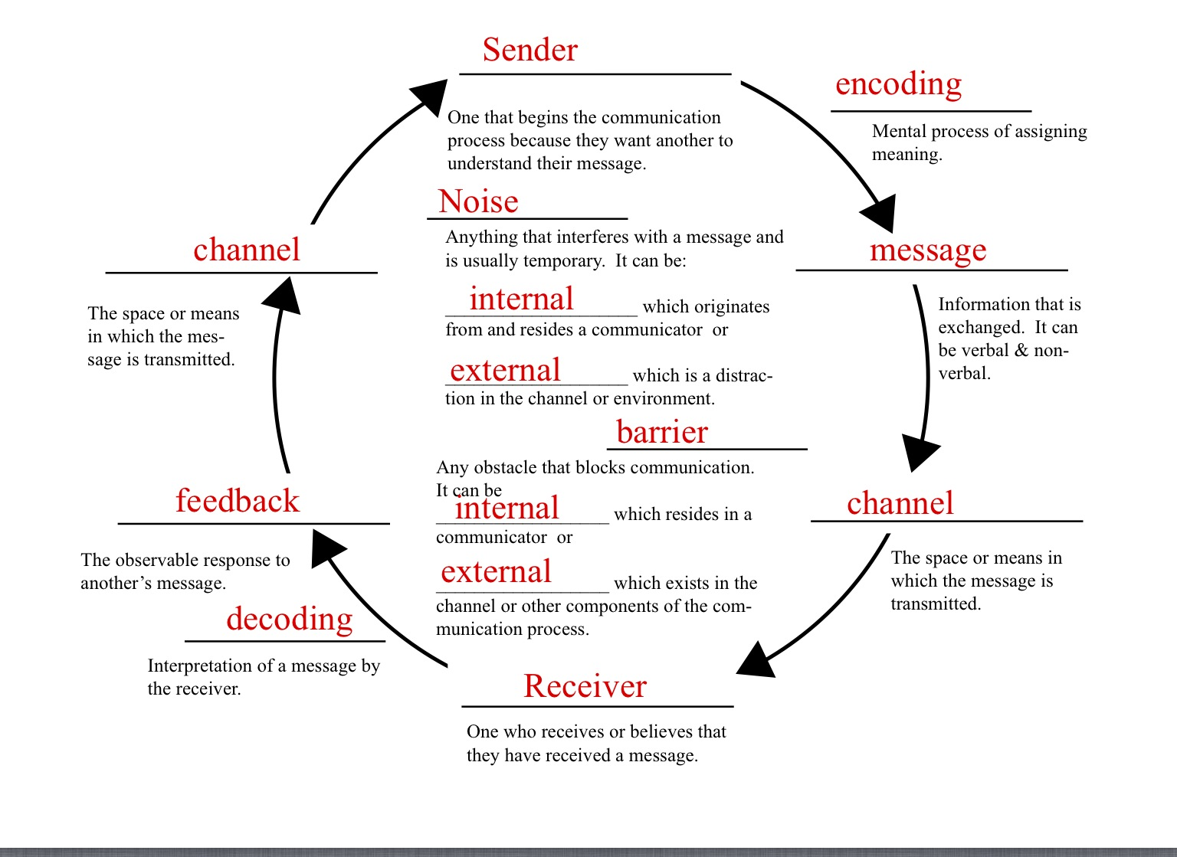
#76
#88
#87
#86
#85
#84
#83
#80
#81
#82
#79
#78
#77
#75

